
HUNGARIAN LANGUAGE AND CULTURE SUMMER COURSE

20 July – 14 August 2026 2x60 class units, 6 ECTS credits
20 – 31 July 2026 60 class units, 3 ECTS credits
3 - 14 August 2026 60 class units, 3 ECTS credits

Program of Studies:
– intensive course
– 6 class units a day, 45 minutes each
Monday: 9:00–10:30; 11:00–12:30; 14:00–15:30, 18:00–19:30 (Folklore Night)

Tuesday-Thursday-Friday: 9:00–10:30; 11:00–12:30; 14:00–15:30
Wednesday: 9:00–10:30; 11:00–12:30
- groups of min. 4 up to 15 students
– from beginner to proficiency level
– language of instruction at beginner levels: English
– special groups for heritage speakers of Hungarian
– placement test before the course starts
– Debrecen Summer School examination and Certificate

The age limit for participants in these courses is 16 years of age. Participants between 14 and 16 years of age can form a separate group of minimum 4 students. In this case, accommodation and supervision shall be the responsibility of their parents.

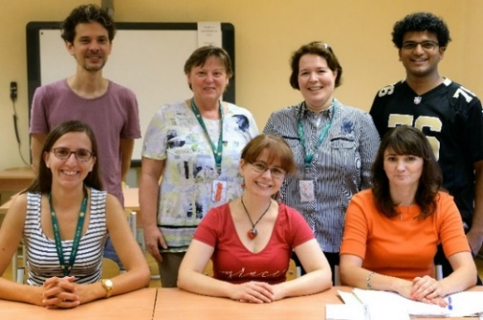
Cultural Activities:
– opening ceremony
– guided tour in Debrecen
– weekend excursions (one in every two weeks)
– Hungarian gastronomy and foodways
– folk dances and folk songs
– quiz
– farewell party
– book sale

Leisure Activities:
– tandem chat with Hungarian students
– disco, karaoke night
– sports

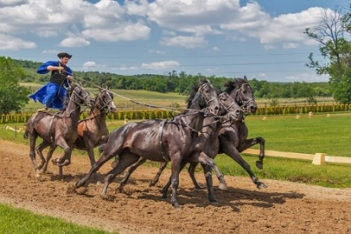
EXTRA Programs:

– sightseeing tour by night
– visiting the Jewish Quarter
– visiting the Reformed College

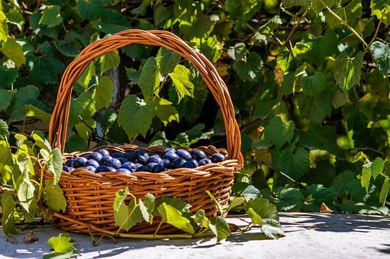


Dates & Reminders:
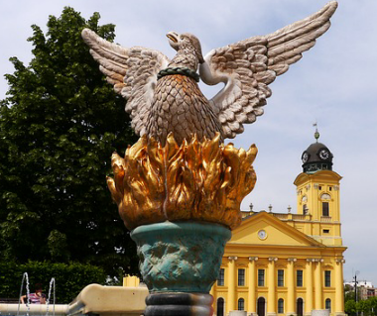
2-week course in July (20 – 31 July 2026)
– registration: 19 July (Sunday), 14:00–18:00
– tuition starts: 20 July (Monday)
– tuition ends: 31 July (Friday)
– check-out time: 1 August (Saturday), before 10:00

2-week course in August (3 – 14 August 2026)
– registration: 2 August (Sunday), 14:00–18:00
– tuition starts: 3 August (Monday)
– tuition ends: 14 August (Friday)
– check-out time: 15 August (Saturday), before 10:00
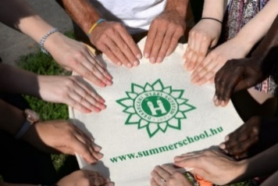
4-week course (20 July – 14 August 2026)
– registration: 19 July (Sunday), 14:00–18:00
– tuition starts: 20 July (Monday)
– tuition ends: 14 August (Friday)
– check-out time: 15 August (Saturday), before 10:00

Accommodation and Meals:
– accommodation: Kossuth Lajos Dormitory II
– upon request, we can book a room in a hotel (please contact the Summer School staff)
– full board (breakfast, lunch and dinner)
– dining options: dinner at nearby restaurants

Application Deadline: 11 June 2026
To apply, please fill in the application form.

Course Fees*: | 2weeks | 4 weeks
tuition fee;  Saturday excursion(s) (1st and/or 3rd week);  Debrecen Sightseeing;  evening cultural programs (including the welcome and farewell dinners) | 940 EUR | 1540 EUR
Other fees: (To be announced later)
On-campus accommodation:
double room | 360 EUR | 725 EUR
single room | 560 EUR | 1125 EUR
Full board | 325 EUR | 685 EUR
* The price of the teaching material (10-30 EUR) is not included in the course fee.

Please read carefully the Useful Information section at our website regarding potentially applicable discounts and/or scholarship possibilities before filling in your application form.

