Applications Open for the 2022 Visualising Climate Crisis Intensive Workshop in Bratislava

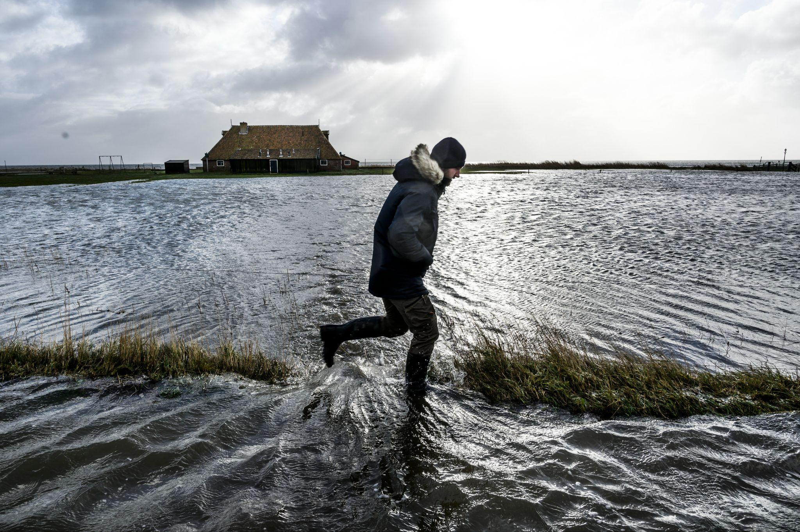

© Kadir van Lohuizen / NOOR

The climate crisis is one of the greatest challenges the world is currently facing: We strongly believe that impactful visual storytelling can inspire climate action. By shedding light on the facts through the power of photojournalism, the immediacy of visual communication has the potential to change history.

That is exactly the reason why the Kingdom of the Netherlands, NOOR foundation and Slovak Press Photo foundation have joined forces to organise a tuition-free, advanced photography workshop for visual storytellers from the Visegrad countries (Slovakia, Czech Republic, Hungary and Poland) entirely dedicated to creating impactful visual stories on the climate crisis.
The tuition-free workshop will take place in Bratislava, Slovakia between 21 and 24 of November 2022.
Content
The Visualising Climate Crisis Intensive Workshop will be led by NOOR mentor, multi-award winning photojournalist Kadir van Lohuizen, who has worked extensively on covering the effects of the climate crisis, and Esther Horvath, award winning Hungarian photographer and a Fellow at International League of Conservation Photographers. The workshop will empower a selected group of 12 participants from four Central European countries (Slovakia, Czech Republic, Hungary and Poland) by facilitating the development of their journalistic, investigative skills and visual mastery over the photographic medium.
By creating stories that expose the impact of the climate crisis on a regional scale, the workshop facilitates long-term capacity building for local visual storytellers, and supports their professional development. This educational programme elevates the level of local communication around urgent climate issues, in order to raise awareness, spark discussion and inspire action .
The workshop is divided in two phases: a physical 4-day intensive workshop, and an online mentoring program lasting for minimum 4 months during the production phase of the works.
The projects will be edited and curated into an exhibition that will open in Bratislava in June 2023 and will travel between 2023 and 2024 to Hungary, Czech Republic and Poland.
During the workshop, the candidates will learn theoretical and technical skills from the tutors, to boost the development of their own visual practices. Participants will discuss, share and learn about the development of a long-term photographic project. Esther and Kadir, who excel at creating compelling visual narratives on the climate crisis, will support the candidates as they develop their stories. Together with the candidates, they will work on the (re)conceptualising, sequencing, and editing of the storytelling projects.
After the completion of the 4-day workshop, the participants will be given a period of a minimum of 4 months to create new bodies of research-based climate photojournalism, based on the initial idea developed during the physical workshop, under the guidance of the tutors via online review, discussion and mentorship. This will allow for the creation of thorough, expansive and high-quality visual journalism.
Application process
All prospective participants must apply with their portfolio, or a selection of images. The application process will be implemented through Picter, an accessible and easy-to-use online resource dedicated to easily navigate and fairly review photography and visual content for contests.
The prospective applicants will be required to send in a motivation letter outlining the project they would like to focus on during the workshop, accompanied by a portfolio of images. We highly encourage applicants to apply with coherent bodies of work, a series of images or visual stories as opposed to portfolios of single images.
The jury, composed of the two tutors, NOOR’s education team, and local experts from V4 countries, will select the 12 candidates (3 from each of the 4 Visegrad countries) based on the quality of their work, factoring in critical aspects such as gender parity, inclusivity and equality, as well as the relevance and feasibility of the proposed projects.
APPLY HERE
Dates: 21-24 november 2022
Time: 9:00-18:00
Location: Bratislava, Slovakia
Application deadline: 26/10/2022 23:59 CET

APPLY HERE

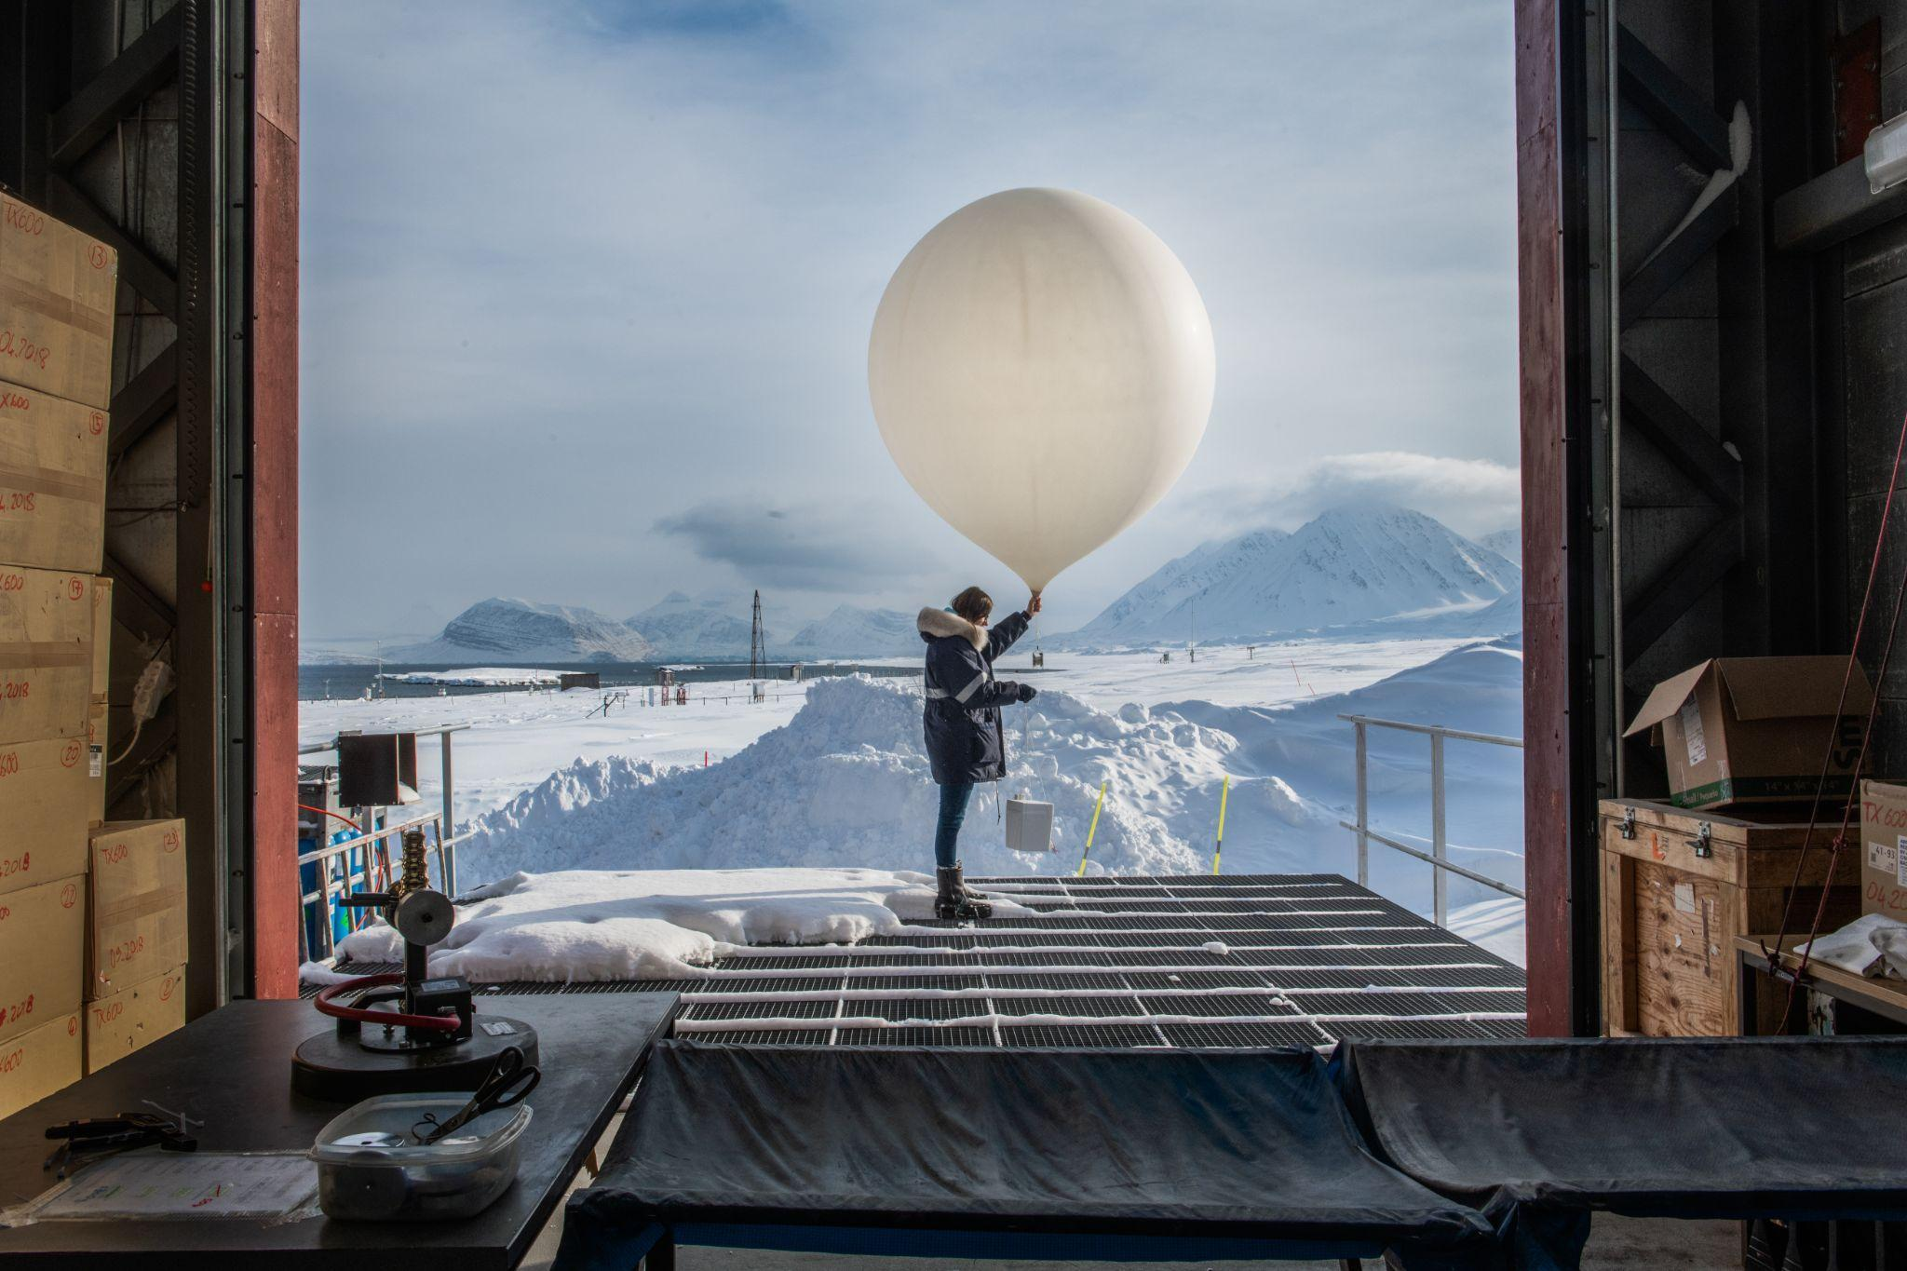
© Esther Horvath
About the Tutors
Kadir van Lohuizen (portrait of Kadir)
(NL) has covered conflicts in Africa and elsewhere, but is probably best known for his long-term projects on the seven rivers of the world, the rising of sea levels, the diamond industry and migration in the Americas. His most recent project ‘Arctic: New Frontier’, created in collaboration with Yuri Kozyrev for the Fondation Carmignac was exhibited at the Saatchi Gallery in London.
Esther Horvath (portrait of Esther)
(HU) is a Fellow of the International League of Conservation Photographers, iLCP, a member of The Explorers Club, and a photographer for the Alfred Wegener Institute for Polar and Marine Research in Germany. A recipient of the Infinity Award from the International Centre of Photography in New York for her work in raising awareness of conservation, environmental justice, and climate change, Esther has dedicated herself to photography in the polar regions, in the Arctic and Antarctic where she has photographed fifteen scientific expeditions, and behind the scenes stories of climate science.
APPLY HERE

